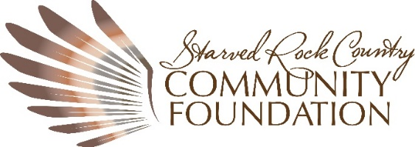

Donor Advised Fund Agreement – Non-Endowed

I. Contribution
We, Joseph, and Nathalie Schmidt, hereby irrevocably give $_________ to the Starved Rock Country Community Foundation, a charitable organization described in sections 501(c)(3) of the Internal Revenue Code. We understand that this is an irrevocable gift, which will be used to establish and maintain a charitable fund of the Foundation, subject to the Foundation’s governing documents and bylaws.

This Donor Advised Fund (DAF) will be known as the Schmidt Family Charitable Donor Advised Fund and will be identified as such during its administration and distribution, unless requested otherwise. The Foundation may also receive additional contributions of cash and/or marketable securities from us or other individuals or businesses as well as distributions of cash and/or marketable securities from trusts, wills, private foundations, or other donor advised funds to either initially fund or add to the Schmidt Family Charitable Donor Advised Fund.

II. Purpose
The fund shall be used to serve charitable purposes at our recommendation, and/or as recommended by the Starved Rock Country Community Foundation.

III. Administration
The Schmidt Family Charitable Donor Advised Fund will be effective upon the acceptance of this agreement by the Foundation. The Fund will be administered in accordance with the normal and customary policies for donor advised funds of the Foundation.

IV. Advisors
The following individuals may serve as Advisors to the Schmidt Family Charitable Donor Advised Fund.

Joseph Schmidt (email, address, phone)

Nathalie Schmidt (email, address, phone)

If, at any time, there is more than one Advisor to the Donor Advised Fund, the Advisors will appoint a designee and all communications to and from the Foundation will be through the designee. If there is no designee appointed, the designee will be the first Advisor listed.

Should the Schmidt Family Charitable Donor Advised Fund cease to have any Advisors, it will be used for the purpose intended by Joseph and Nathalie Schmidt at the discretion of the Foundation’s Board of Directors.

V. Distribution
The Foundation welcomes recommendations from the Advisor about distributions from the fund. Available funds may be distributed in increments of at least $250 subject to Foundation approval.
- All recommendations are advisory in nature. The Foundation will independently determine whether recommendations it receives are consistent with the Foundation’s charitable purposes. The Foundation may accept or reject recommendations.
- The Foundation cannot make distributions to fulfill any pledge, obligation, or membership, or to support any activity from which a Donor, Advisor or related party will receive a benefit.
- The Foundation will not make payment to any individual, or to a non-charitable (for-profit) organization.

VI. Fees
The Foundation will assess certain administrative and investment management fees to Schmidt Family Charitable Donor Advised Fund in accordance with the Foundation’s published fee schedule, as amended from time to time. The current Administrative Fee is 2%. Bank investment fees vary. The Foundation may also assess the fund to cover any unusual expenses incurred in connection with the contributed assets, including the cost of disposing of them, and in the administration of the Fund.

VII. Investments
The assets of the Fund shall be invested according to the Foundation’s investment policy, as it may be amended from time to time by the Foundation’s Investment Committee with the approval of the Board. The Investment Policy is available upon request.

VIII. Anonymity/Publicity
To recognize and honor our donors, the Foundation’s policy is to include our donors’ names in publicity about the Foundation unless they wish to remain anonymous. Please check the box below that best describes your wish regarding publicity:

___ I have no objection to the inclusion of my name in Foundation publicity

___ I do not wish to have our name included in Foundation publicity and we wish to be listed as anonymous donors.

By:

_____________________________________ ________________
DONOR Date
_____________________________________ ________________
DONOR Date

By:

_______________________________________ ________________
President and CEO, SRCCF Date

Approved by the SRCCF Board of Directors __________________
Date

Enclosure – Donor Advised Fund Information Sheet

