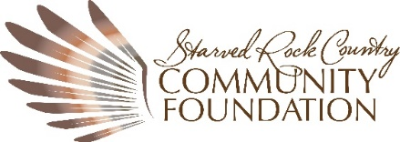

Donor Designated Fund Agreement

I. Contribution
______________________________ hereby irrevocably gives $_________ to the Starved Rock Country Community Foundation (SRCCF), a public charitable organization described in sections 501(c)(3) of the Internal Revenue Code. We understand that this is an irrevocable gift, which will be used to establish and maintain a charitable fund of the Foundation, subject to the Foundation’s governing documents and bylaws.

This Donor Designated Fund (DDF) will be known as the _________________________________ Donor Designated Fund and will be identified as such during its administration and distribution, unless requested otherwise. The Foundation may also receive additional contributions of cash and/or marketable securities from me or other individuals or businesses as well as distributions of cash and/or marketable securities from trusts, wills, public and private foundations, or other donor advised funds to either initially fund or to add to the __________________________________ Donor Designated Fund.

II. Purpose
The fund shall be used to provide financial support to the _____________________________.

III. Administration
The __________________________________Donor Designated Fund will be effective upon the acceptance of this agreement by the SRCCF. The Fund will be administered in accordance with the normal and customary policies for Donor Designated Funds of the SRCCF.

IV. Advisors
The following individual(s) may serve as Advisors to the Donor Designated Fund:
1.
2.
If there is more than one Advisor to the Donor Designated Fund, all communications from the Foundation will be sent to the first Advisor listed above. Should the Fund cease to have any Advisors, it will be managed at the discretion of the Foundation’s Board of Directors for the purpose intended by the donor.

V. Distribution
The Foundation welcomes recommendations from the Advisor about distributions from the fund. Available funds may be distributed in increments of at least $250 subject to Foundation approval. Please refer to the attached Variance Power document for more information regarding distributions from the Designated Fund.
The Foundation cannot make distributions to fulfill any pledge, obligation, or membership, or to support any activity from which a Donor, Advisor or related party will receive a benefit.
VI. Fees
The Foundation will assess administrative and investment management fees against the ______________________________Donor Designated Fund in accordance with the Foundation’s published fee schedule, as amended from time to time. The current Administrative Fee is 2%. Investment fees vary. The Foundation may also assess the Fund to cover any unusual expenses incurred in connection with the contributed assets, including the cost of disposing of them, and in the administration of the Fund.

VII. Investments
The assets of the Fund shall be invested according to the Foundation’s Investment Policy. It may be amended from time to time as determined by the SRCCF Investment Committee and with the approval of the SRCCF Board of Directors.

VIII. Anonymity/Publicity
To recognize and honor our donors, the Foundation’s policy is to include fund and donor names (when appropriate) in publicity about the Foundation. Please check the box below that best describes your wish regarding publicity:

____ I have no objection to the inclusion of the ________________________________Donor Designated Fund in Foundation publicity
____ I do not wish to have our name included in Foundation publicity and we wish to be listed as anonymous donors.

This agreement shall be effective on ______________________, as approved by the SRCCF Board of Directors.

BY: ___________________________________ __________________ _______
Signature Printed Name Date
BY: ______________________________________ ____________________ ________
SRCCF President/CEO Printed Name Date

ATTACHMENT – VARIANCE POWER DOCUMENT
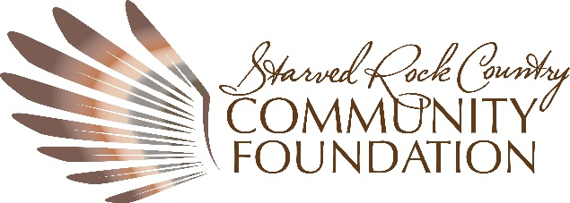

Understanding Variance Power – With so many nonprofits struggling amidst the economic fallout created by the Global COVID-19 Pandemic, what does a donor do to ensure that an estate gift established to support their favorite nonprofit remains impactful if the nonprofit ceases to exist at the time the gift is realized? How can that donor’s philanthropic legacy be protected for future generations if a nonprofit organization goes out of business? Enter the work of a Community Foundation.
Community Foundations, such as the SRCCF, have a unique ability to protect a donor’s interests long after that donor’s lifetime. This protection falls under the ability of SRCCF’s Board, made up of community leaders, to use its variance power to ensure that the donor’s intent is fulfilled in perpetuity. Through the terms of a standard fund agreement between the donor and the SRCCF, the donor can outline their specific charitable intentions and acknowledge that should their gift to a specific nonprofit not be possible, the Board has the authority, through their variance power, to follow-through with the gift’s original intention.
SRCCF holds a variety of types of funds including Donor Advised Funds, Designated Funds, Field of Interest Funds, Endowment Funds, Agency Funds, and Corporate Advised funds, which may benefit a specific nonprofit organization or a variety of nonprofit organizations. The funds can be endowed, partially restricted, or unrestricted. To see how variance power works, take this example: perhaps a donor who is fond of a local mentorship program has set up a designated endowment fund to benefit that organization through the donor’s estate plan. That donor’s designated endowment fund is established to provide income in perpetuity to the mentorship program. Twenty years later, the donor has passed on and the legacy gift has been realized, but the program no longer exists. The Community Foundation has the authority, through the Board’s variance power, to redesignate those funds to a similar nonprofit organization whose work most closely aligns with the donor’s original intent. By identifying a similar alternative nonprofit organization within the community that offers a mentorship program, the Board protects the donor’s legacy.
Variance power not only allows a donor’s charitable wishes to be followed and continue in perpetuity, but also allows SRCCF to respond to the changing needs of nonprofit organizations within the community. It’s a winning combination for the donor, the nonprofits, and future generations.

