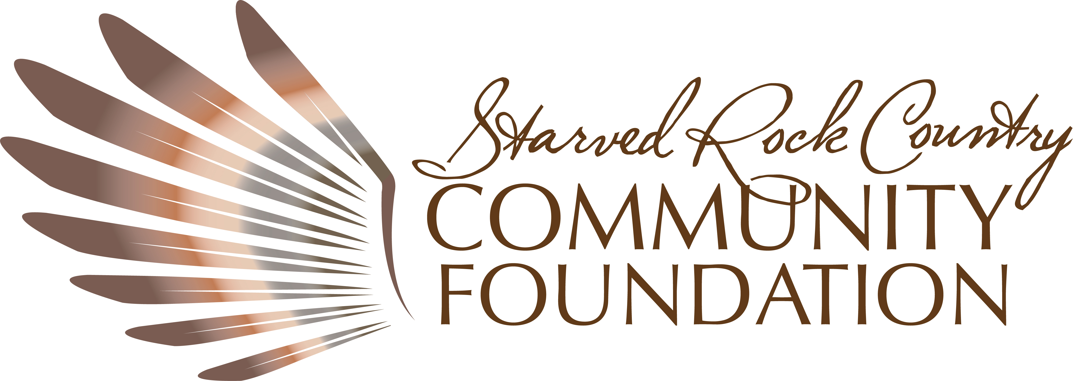

DONOR DESIGNATED FUND

The fund that enables you to support the charitable organization named in the agreement when the fund is established. Should the organization cease to exist or no longer offers the programs you intended to support, the Foundation will work with you to identify another nonprofit organization that meets your charitable goals. By establishing a donor-designated fund, you and the donors to the fund will benefit from the Foundation’s tax advantages for charitable deductions, our investment expertise, and our assurance that grants from your fund will be made to the charitable organization of your choice, or for the purpose you intend, long into the future.
Personal: You can ensure that a charitable program or organization that has special meaning for you will receive financial support for years to come.
Flexible: You and others can contribute by cash, check, or credit card. We also accept donations of almost any asset, including shares of stock, real property and assets from an IRA that is eligible for charitable rollover. All contributions are irrevocable gifts, which will be used to establish and maintain the fund, subject to the Foundation’s governing documents and bylaws.

Enduring: The fund can be an endowment, assuring that the organization you choose will receive support in perpetuity. Or you can create an expendable fund, from which grants of any amount can be made at any time.
Efficient: SRCCF holds, manages, and invests the assets, provides a quarterly investment statement, and includes the fund in our annual tax reporting.
Fast: A designated fund can be set up quickly.
Ideal for Families and Individuals:
- Have a special relationship with an institution that they would like to support over a long period of time.
- Want to help an organization expand its funding base.
- Value seeing their charitable assets managed by the Foundation to help ensure growth and the availability of more grant dollars.
- Value knowing that even if the charity is no longer operating or has changed its mission, the Foundation will identify another group that meets the donors’ charitable intentions.

Financial Facts
- The Administrative Fee for Donor Designated Funds is currently 2%. In addition, each fund is charged investment management fees.
- The minimum opening gift is $1000. There is no fee to establish a fund.
- The minimum amount for each grant made from the fund is $250.00.

Ready?
- Name the charitable organization you are designating to receive grants.
- Make an initial contribution.
- Recommend grants when you see fit.

